Chapter 5 Electrical physics

Chapter Test Answers Total marks 45

Section A

Question 1

C 1

Question 2

D 1

Question 3

C 1

Question 4

B 1

Question 5

D V = 3.0 V for batteries in series.

 1

Section B

Question 1

**a.** *F* = *Eq*

= 5 × 10-4 × 1.602 × 10-19

= 8.01 × 10-23 N down the page 3

b. The force on the particle causes it to move downwards and speed up (accelerate). 2

Question 2

Chemical potential energy stored in the chemicals in the battery is transformed into electrical potential energy as the chemical reactions separate charges within the battery.

When the circuit is connected the charge separation establishes an electric field within the wires. This electric field exerts a force on the electrons within the wire. This results in a conversion of electrical potential energy to kinetic energy.

Kinetic energy of the electrons is transformed into heat and light within the bulb when electrons collide with the atoms within the filament of the bulbs.

1 mark for each of the transformations. 3

Question 3

a.  = It = 4.5 × 5 = 22.5 C 1

b.  = 9 × 4.5 × 1 = 40.5 J 2

Question 4

a. E = Pt = 200 × 4 = 0.8 kWh or 200 × 4 × 3600 = 2.88 × 106 J 2

b. Cost = 0.2 × 1 × 60 J 1

= 12 cents 1

Question 5

a. 3

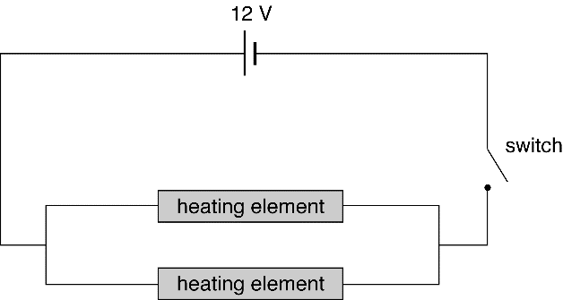

1 mark each for a parallel circuit and correct symbols and labels.

b. 2

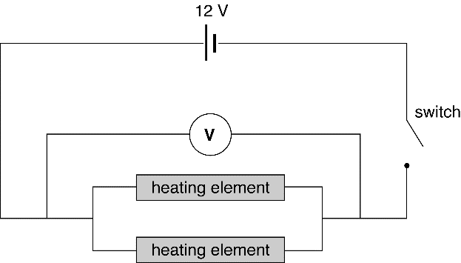

1 mark each for correct symbols and correct positioning of voltmeter leads.

c. V = 12 V 1

d. V = 0 V 1

e. A 1

f. 



*RT* = 150 Ω 2

g. Answer is consequential:

 0.08 A = 80 mA 1

h. Even if the person was exposed to the bare wires, it would not cause an electric shock   
as the voltage is only 12 volts and this is not enough to send any significant current   
through a person. 1

Question 6

a. Device P, as its I–V graph is linear. 1

b. 

Resistance is reciprocal of gradient. Choose two points to determine:

R = 40 Ω. 2

c. From graph, when I = 200 mA ⇒ V = 6 V. 1



This value depends on the conditions in the rest of the circuit and will change   
as the current through the device changes. 1

Question 7

a. Since current is constant at all points in a series circuit, I = 100 mA. 2

b. This is requesting the voltage across device P.  
From the device P graph, when I = 100 mA, V = 4 V. 2

c. This is requesting the voltage across device Q.  
From the device Q graph, when I = 100 mA, V = 6 V. 1

or EMF = VP + VQ ⇒ 10 = 4 + VQ 1

⇒ VQ = 10 – 4 = 6 V.

d. From part c, when I = 100 mA = 0.100 A, V = 6 V. So:

 2